Report Viking’s Project at Week 28
Table of Contents
1) Introduction : 1
2) Viking’s Project Overview : 3
3) Viking Summary Earned Value report : 5

- Introduction :

This project will be monitored and controlled by a using a select set of the Earned Value Management (EVM) metrics: Schedule Performance Index (SPI) and Cost Performance Index.
In order to effectively use CPI and SPI, the project will be partitioned by Control Account Plans (CAPs, Project Deliverables. The Earned value data will be captured from weekly timesheets produced by all team members. The Viking Project Management team is chartered to incorporate the week time into the schedule, calculate the metrics, and perform causal analysis. This information will be summarized and presented to the Steering Committee in association with the charts.
Data represent in chart include :

Data Field | Description
BCWS | Budgeted Cost of Work Scheduled. ... For a <Resource>, it is the rolled-up summary of a resource's BCWS values for all assigned tasks
BCWP | Budgeted Cost for Work Performed; Earned Value; the dollar amount of work that was actually accomplished; [Budget] X [percent complete]
ACWP | Actual Cost of Work Performed during a given time period; money spent up  to the current date. ... Cost Performance Index, CPI = BCWP / ACWP
CPI | Cost Performance Index is the calculation of Earned Value (EV) divided by Actual  Cost (EC), CPI = BCWP/ACWP
SPI | Schedule Performance Index is the calculation of Earned Value (EV),BCWP  divided by the Planned Value (PV), a.k.a. SPI = BCWP/BCWS
EAC | The EAC gives an idea of the final costs of a project. It takes into account the  original budget (BAC), the Earned Value and the Cost Performance Index of the  already completed works.  EAC = ACWP + ((BAC - BCWP)/CPI
BAC | Budget at Completion is the original budget requested for the project or program represented by the end point on the BCWS curve
SV | Schedule Variance . SV = BCWP - BCWS
CV | Cost Variance . CV = BSWP - ACWP

Table_1 : Data represent

The Earned Value data in this assignment will be collected from Viking_EV_Data-up_to_w28.xls.
- Viking’s Project Overview :

Summary Task | Baseline |  | Current |  | Release Status | Status
Summary Task | Start | End | Start | End | Release Status | Status
PM & EV | W 1 | W 48 | W 1 | W 48 | On Target | As per schedule
Release 1: Deliver GUI & User Documentation | W 3 | W16 | W 3 | W 16 | Completed | Completed on time
Release 2 : Deliver Online Product | W 3 | W16 | W 3 | W 24 | Completed | Completed on time
Release 3: Deliver Offline Product | W 3 | W36 | W 3 | W 40 | Behind Schedule | Behind Schedule 4 Week
Release 4: Deliver Final Product | W 36 | W 48 | - | W54 | Not Started | Potentially behind schedule by 6 or more weeks because of the delay in critical path

Table 2: Schedule Slippage at Week 28

- Viking Summary Earned Value report :

The figure below shows Earned Value Report of third release.

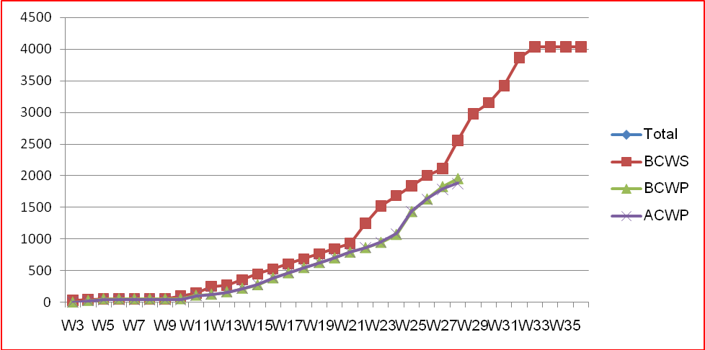

Figure 1: Release 3 – Earned Value Report
In Viking_EV_Data-Up_to at week 28:
- BCWS = 2556.41
- BCWP = 1953.75833
- ACWP = 1880.00
- BAC = 2864.00
Cost Variance (CV) = BCWS – ACWP = 2556.41 – 1953.75833 = 602.65117
Schedule Variance (SV) = BCWP – BCWS = 1953.75833 – 2556.41 = -602.65117
Estimate at Completion (EAC) = BAC / CPI = (2864.00 * 1953.75833)/ 1880.00 = 2976.36
Estimate to Complete (ETC) = EAC – ACWP = 2976.36 – 1880.00 = 1096.36

→ The project is behind schedule by $602.65117 (2 week or more).
→ At the current rate, the project performance will be such that it will be completed in $2976.36 as opposed to a planned budget of $2864.00. Comparing with Figure_3, the project can be delayed 4 – 6 week or more.
→ Project performance at this rate means that the project requires $ 1096.36 to be completed.

